Assessment of Spruce Pine and Fir Seedlings for Export to Nepal

Landon Hoeper
Thursday 8:30 AM
AGR 1110
Tuesday, December 1, 2015

Introduction
This paper has been created to help evaluate the potential benefits and challenges of exporting live Canadian Spruce Pine or Fir seedlings to Nepal. This report is divided into two main parts; Part I focuses on the product, evaluating how it works, what it costs, the labour it requires, market opportunities benefits to Canada etc. Part II assesses the products export potential to Nepal and how it will help Nepal’s agriculture systems while benefiting the environment. This export idea could also be used to help other countries suffering from similar challenges as Nepal regarding sustainable forestry.

Part I: In depth evaluation of Canadian Spruce Pine, or Fir Seedlings
- Description of product
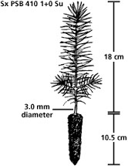
This product is simply young spruce, pine, and fir trees that are grown to a mature stage in which the plant would survive if it were transplanted. This means the plant must have a well developed shoot and root system. When selecting a stock for reforestation, one must seriously consider the quality and characteristic of plants in order to see best results in the field (The Government of British Columbia, 2010). Factors that should be taken into consideration while selecting stock is the ecological suitability of the growing site, a species that best matches the growing conditions is crucial (The Government of British Columbia, 2010). Seedling size is the most important factor to be considered when selecting stock. Picking the correct species and seedling size will optimize results or growing area. Figure 1 shows an average sized spruce seedling used in Canadian reforestation.
Figure 1
www.for.gov.bc.ca/hfp/publications/00078/choose.htm
- How product is grown
These seedlings are grown in open fields or greenhouses. Greenhouses are more ideal for Nepal export because Nepal has different environmental conditions than Canada. Environmental conditions can be better replicated within a greenhouse compared to outdoors where there is less environmental control. An example of this could be a comparison of soil pH. The pH of soil is very important in terms of growing trees, because certain trees prefer a certain pH. It would be best if trees are grown in a similar soil pH as in Nepal so the trees do not go into shock after being transplanted (University of Minnesota, 2015).
There are many greenhouse tree nurseries in Canada that focus on the production of Spruce, pine, or fir seedlings for reforestation. Although a particular that stands out is Coast to Coast Reforestation Inc. from Edmonton Alberta. This company has large volume production for reforestation programs and offers an ideal service called cold storage which stores plants in a freezer making them dormant. This allows Coast to Coast to store the product until the purchaser is ready for their product to be shipped. Other companies that produce tree seedlings for reforestation can be found using this link:
http://www.canadian-forests.com/silviculture-nurseries.html
- Machinery Required and Cost
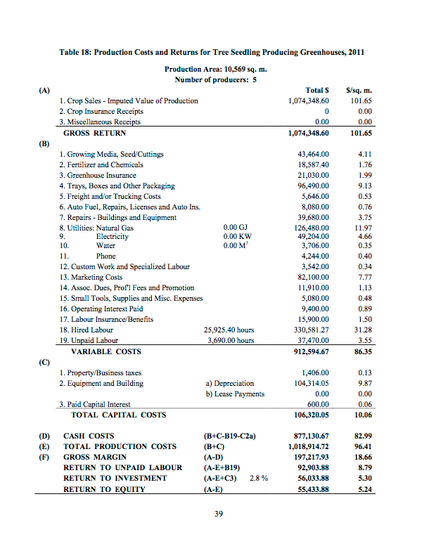
Very little machinery is required for the production of spruce pine and fir seedlings. The seedlings need irrigation for greenhouse growing. The type of irrigation system which is commonly used for greenhouse seedling production is an overhead sprinkler system which runs multiple times daily (S. Bowling, 1987). Lighting systems as well as temperature regulation equipment is needed to assist and encourage photosynthetic reactions within seedlings for faster growth of seedlings (S. Bowling, 1987). Trucks are needed for shipping the product from the greenhouse growing site to it’s storage location. The seedlings are stored in a facility which require freezer and cooling equipment to keep the product in a dormant state (Coast to Coast Reforestation, 2015).

http://www1.agric.gov.ab.ca/$Department/deptdocs.nsf/all/agdex4369/$FILE/821-59.pdf
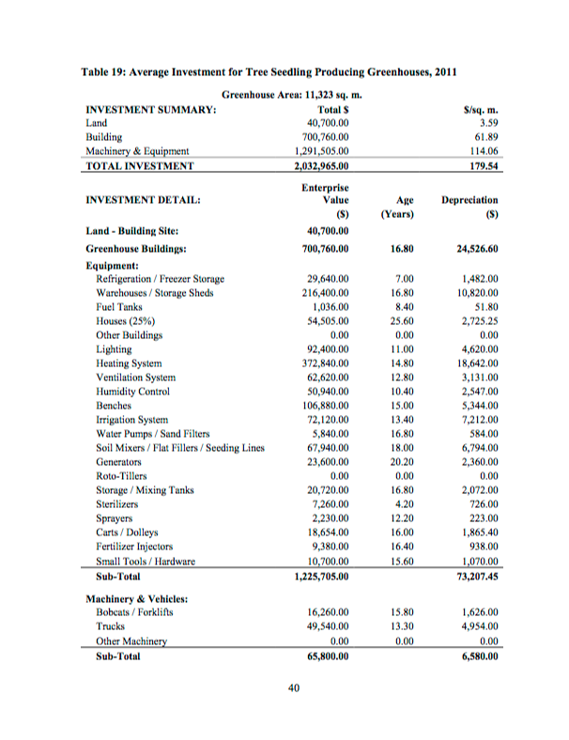
http://www1.agric.gov.ab.ca/$Department/deptdocs.nsf/all/agdex4369/$FILE/821-59.pdf
Table 18 and 19 display the costs associated with the production of greenhouse seedling production in Alberta. The most significant costs in greenhouse seedling production are hired labour, natural gas, marketing, and electricity respectively. However, the initial investment to start up greenhouse production is quite expensive (Government of British Columbia, n.d.).
- Inputs/ Labour
As mentioned in part iii and displayed in Tables 18 and 19, labour is the most expensive segment of the tree production industry. Labour is limited, and generally difficult to acquire for this type of industry (FAO, n.d.). A very diverse skill set is required in tree production, there is lots of machinery and technological applications in modern greenhouse tree production. However, some of the labour can be quite intensive and repetitive. Coast to Coast is a fairly technologically advanced company with lots of self regulating and automatic equipment, replacing unskilled workers. Which such technological based equipment, a skilled worker is required to operate machinery, which causes each unit of labour to be very expensive. Labour adds up to approximately 1/3 of company costs. Inputs for tree production consist of seed cuttings, fertilizer and chemicals, insurance, growing trays, freight/transportation, auto fuel, repairs, licenses, auto ins., building repair/maintenance, natural gas, electricity, phone, custom work, marketing, tools, operating interest paid, hired labour, and unpaid labour.
- Marketing opportunity
Canada has one of the globes largest and most modernized forestry industries (Government of Canada, 2013). Sustainable forestry is very important to the Canadian economy. Many regulations are placed to ensure the industry cannot clear cut forests without re-planting (Government of British Columbia, 2010). Due to the high precaution of reforestation there are many tree nurseries located across Canada to ensure replanting efficiency. Nepal, being less developed than Canada, does not have a well developed reforestation program in place due to limited resources and lack of funding (Sir Edmund Hillary Foundation, n.d.). Canada can help Nepal reforest because of our abundance in tree nurseries. Canada has an abundance of all of the resources Nepal needs to reforest. This makes for an excellent marketing opportunity. Nepal desperately needs to reforest with only 30 percent of the forest cover remaining (R. Butler, 2006). Both the Canadian economy and the Nepalese environment would benefit greatly from exporting these seedlings. This product would ideally be marketed to the Government of Nepal or smaller communities within Nepal who would like to sustain and regrow their forests.
- Benefits to Canada
Exporting spruce pine and fir seedlings to Nepal holds many possible benefits for the Canadian economy. Canadian nurseries will have increased sales and production, allowing them to expand and become more profitable. The expansion of these nurseries will allow companies to have a lower production cost per unit, while giving Canada a stronger more anchored seedling industry. Tree exportation from Canada to Nepal opens up a new global exportation opportunity to other countries in southern Asia who are also suffering from deforestation. This will expand the Canadian seedling industry even further, creating jobs, and benefiting the Canadian economy as a whole.
- Environmental sustainability of growing seedlings in Canada
Environmental sustainability is very important to Canadians. Seedlings however do require an abundance of resources to grow (Government of Alberta, 2003). In greenhouse seedling production a significant amount of resources is needed, all of these resources used will effect the Canadian environment. Major resources needed for greenhouse tree production are natural gas, electricity, water, and fertilizers/chemicals which all which have a negative impact on the environment (EPA, 2012). However, the benefit of growing in a greenhouse is that the chemical use is isolated from the outdoor environment resulting in less contamination (BC Greenhouse Growers Association, 2004). Water within greenhouse that was contaminated can be treated and reused. Additionally, greenhouse production has a smaller ecological footprint since production is so intensive (BC Greenhouse Growers Association, 2004). Heat and electricity are still required in greenhouse production. Most modern greenhouses are now equipped with heat conservation technology which stores heat from carbon dioxide production on hot days and uses it for colder days.

Conclusion of Part I
To conclude the product discussed is spruce, pine, and fir seedlings grown and produced by Coast to Coast Reforestation Inc. for forest sustainability. The lumber produced by these trees is very versatile and has many practical uses which are beneficial to a developing country such as Nepal. Nepal is suffering badly from deforestation and does not currently have the resources available to grow and produce seedlings. Most of the land in the Nepal is mainly needed for crop agriculture. This makes Canada an ideal exporter for seedlings.

Part II: Export Potential of Canadian Spruce Pine or Fir Seedlings to Nepal
- Nepal evaluation
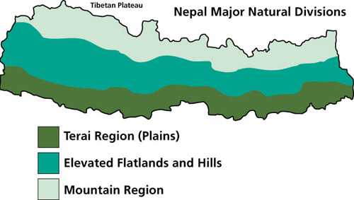
Nepal is a small landlocked country located in the southern area of Asia between India and China. The landscape is very diverse with 3 major ecological zones known as the Mountain, Hills and Terai (Kullabs, 2015) as displayed in Figure 2. The Himalayan region is in the north which is mainly inhabitable (Kullabs, 2015). Very little vegetation is present. The hill region is located south of the the Himalayas which is full of deciduous forest and terraced hills for agriculture (Kullabs, 2015). Then in the very south is the Terai region – a very flat fertile land area which is excellent for crop agriculture (Kullabs, 2015).
Figure 2
The main forested areas in Nepal are located in the Terai and hills regions. These forest cover in these areas is continuously decreasing on a yearly basis as displayed in Figure 3. Deforestation in Nepal is a very important issue because wood it is used to heat 75 % of homes and plays a large role in Nepal’s economy (P. Tamrakar, 2003). Currently less than 30 percent of Nepal’s forest cover remains (P. Tamrakar, 2003). Nepals forest cover decreases at a rate of 1.35 % per annum (R. Butler 2006). At this rate the forest is currently not sustainable for future generations as Nepals population has an annual growth of 2.17 percent (P. Tamrakar, 2003).
Forest area decline and population growth in Nepal during the last two decades
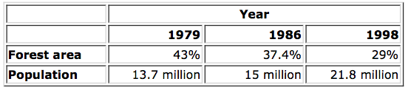
Figure 3
http://www.fao.org/docrep/007/ad872e/ad872e02.htm
- Transportation
One of the downfalls of exporting live trees is that they are very sensitive to handling and changing environments. The product must also be shipped in a timely manor to lessen the chance of it degrading. Since Nepal is landlocked the spruce, pine, or fir seedlings will need to be shipped by plane Edmonton to Kathmandu via cargo plane. A rough estimate on shipping is $940.00 CAD for a standard sized pallet (1.2m x 1m) holding approximately 500 seedlings weighing approximately 45 kg (A1 freight, 2014). This estimate does not include the extra cost to ship the product in a temperature controlled environment which would be needed to ship tree seedlings. Upon arrival the trees would be distributed to surrounding reforestation programs by truck which cost $0.046/ton*km plus $0.31/km in Nepal Shown in Figure 4.
Trucking Costs in Southern Asia
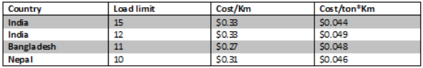
Figure 4
(Source: Subramaniam, Arnold p. 36)
http://12.000.scripts.mit.edu/mission2014/solutions/roads-in-south-asia-and-south-east-asia

- Planting trees
Trees will be handed of to reforestation programs who co-ordinate and plan tree planting locations. The labour for these programs is generally volunteer based. Major reforestation programs within Nepal are The Sir Edmund Hillary Foundation, EHN, and Khumbu. Approximately 1400 trees are needed to replant one hectare for full forest regrowth (Government of British Columbia, 2012).

- Cost of Seedlings
Coast to Coast Reforestation Inc. does not have unit available online because most of their work is contract based through government contracts. Ferguson Forest Centre is a nursery located in Kemptville, Ontario which focuses on tree sales mainly for landscaping purposes. This would likely result in slightly higher prices than a larger volume contract which would be made with a larger reforestation nursery such as Coast to Coast Reforestation Inc. The product is identical however. The cost of seedlings from each species is displayed below in Figure 5
Cost of Spruce, Pine, or Fir Seedlings
 | White Pine | White Spruce | Fraser Fir
Cost per unit (order over 1000) | $0.51 | $0.71 | $0.91
Figure 5 http://www.seedlingnursery.com/product/bare-root-seedlings
These trees are extremely affordable as well as a great investment. They will turn into a mature tree after 25-40 year which is a useful resource for future generations to use for construction, furniture, shavings, or pulp/paper products (S. Kinney, 2013). The return for an investment is quite time consuming. When harvested the product, it can be refined into products such as furniture which drastically increases the value of the raw wood. This will easily pay of the initial investment of purchasing the seedlings. This price point is very realistic and affordable. Shipping does increase the cost per unit by more than double which is major downfall.
- Needs and Benefits to Nepal
Exporting trees will help meet Nepal’s need for reforestation but it will also bring multiple benefits. Reforestation as previously mentioned is extremely important for Nepal because their country is so dependant lumber for many applications such as fuel wood, construction, furniture, animal bedding etc. The population of Nepal is also increasing steadily at 2.17 % a year (P. Tamrakar, 2003) which is quite rapid. This means that future generations will consume even more lumber than the current generation. Currently there is very little effort being put into the reforestation of Nepal (FAO, 1997). The main focus of the Nepalese people is putting food on their tables and keeping their homes warm. Most residents would not have time or money to plant and regrow forests. Reforestation action must be taken soon before this issue becomes to far gone.
- Environmental benefits
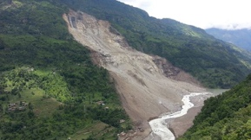
Reforestation is also important from the environmental perspective. Most of the clear cut forest areas in Nepal are located in the hill region (FAO, 1997). Tree root systems are vital for holding the soil structure together and preventing the land from sliding (Queensland Government, 2015). When a mass amount of soil slides down a slope it is known as a landslide (Queensland Government, 2015). In many areas of the hill region large steep slopes are left bare with no vegetation making it prone for landslides. Landslides are deadly natural disaster and have been known to wipe out farms, homes, and entire villages as displayed in Figure 6. Root systems also play a vital role in preventing water erosion. Root systems slows the movement of the water and also holds the soil structure preventing it from washing away (Queensland Government, 2015).
Figure 6
http://blogs.agu.org/landslideblog/2014/08/07/bhote-kosi-landslide-3/c8bTJAhWDGD4KHX9lDmEQjRwIBw&url=http%3A%2F%2Fblogs.agu.org%2Flandslideblog%2F2014%2F08%2F07%2Fbhote-kosi-landslide-3%2F&bvm=bv.108194040,d.dmo&psig=AFQjCNHd6O3P2bLtagOfI8-rrRdAkeTsTQ&ust=1448860798493408
On a larger scale reforestation helps with global warming because new trees can assist in reducing the concentration of CO₂ in our atmosphere (M. Giurca 2012). As we probably know CO₂ is very important for the photosynthetic reaction within trees and is also one of the main “Greenhouse Gases” that causes global warming. Trees take in CO2 and release oxygen which is better for our atmosphere and slows global warming (M. Giurca, 2012).
- Trade and Subsidy Barriers
Spruce, pine, and firs trees are living plants which are mainly native to North America. Exporting and Importing live trees can be a very daunting task. There are many ecological concerns or risks that a live plant can bring to a foreign country. Live plants are heavily regulated because they pose many threats such as carrying invasive or unwanted species into a new ecosystem. Invasive species may destroy or harm the bionetwork of native organisms. Spruce, pine, or fir tree seedlings are not prohibited to import into Nepal but are regulated (Government of Nepal 2012). There is a duty tax of 6.5 % or 10 % depending on its purpose (Government of Nepal 2012). More research would need to take place in this sector if this export idea ever was launched. Special arrangements with governments may be needed. Seedling importation for reforestation would likely would not be charged duty. 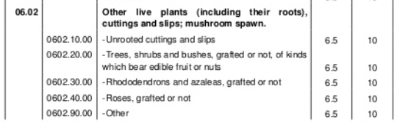
Figure 7
Nepal Import Regulations

http://www.slideshare.net/BarryDuplantis/nepal-customs-import-classification-and-duty-hs-207071201314engdoc2012-version-22e39eaf890ffd3cafd345b51718ec81
- Potential customers
Purchasing trees is likely not one of the largest concerns among Nepalese people. Currently there still is firewood available to consumers so residents may not be aware of the deforestation occurring. This means there are very few potential customers who would be interested or could afford to import this product. It would be in best interest of the government to purchase these for forest sustainability. Most Nepalese forests are government controlled (Ministry of Forests and Soil Conservation, 2015) meaning most residents have no reason to invest in them because they are not theirs. Most forest is conservation area or national parks (Ministry of Forests and Soil Conservation, 2015).
The seedlings could also be imported then distributed to farmers who may be interested in possibly creating their own nursery to help maintain soil structure of their properties. Most of these famers would be living in the hilly region and want to prevent erosion. In the hill region there is limited connection to the outside world. Some personnel would be needed to organize a program to organize the distribution of seedlings from the main shipment out to smaller communities. The Ministry of Forest and Soil Conversation located in Singhadurbar, Kathmandu, Nepal would be an ideal organization to contact regarding this export idea (www.mfsc.gov.np)

Ministry of Forests and Soil Conservation

Singhadurbar, Kathmandu, Nepal
Telephone : 4211567
Fax : 977-1-4211868
Email : info@mfsc.gov.np, webmaster@mfsc.gov.np
Spokesperson: Krishna Prasad Acharya
Joint Spokesperson: Yajna Nath Dahal

- Recommendation, Marketing plan, Conclusion
Importing live plants from across the globe clearly will not be a simple and very practical idea. It would probably make more sense for Nepal to fundraise money to start up their own tree nursery for their reforestation. The challenges and risks of shipping live plants are very high and complications can easily occur threating the loss of plants. Fundraising will allow Nepalese purchasers of the product to save the expensive shipping cost. Seedlings would best be grown in Nepal because is much more cost effective. Growing trees is not a very complicated or difficult task.
The point of this research paper is to evaluate the possible idea of shipping live plants to get Nepal’s reforestation started until they later have the resources to begin their own reforestation programs as well as display the many advantages growing Canadian spruce, pine, or fir trees might bring to the country of Nepal. Re-growing all of Nepal’s forests with Canadian grown seedlings is not economical or affordable in any way. The introduction of this new tree species however may bring great qualities to help with Nepal’s struggling economic system.
Marketing strategies that could help with the advancement of this export idea would be to organize a type of charity or fundraiser that could help reduce the cost of growing and shipping trees. A great way to fundraise is to offer a tangible product such as clothing for sale to consumers in a developed country such as Canada and have a certain portion of these funds go toward the tree reforestation project similar to the Tentree Clothing Company®. Tentree Clothing Company® claims they plant 10 trees in deforested countries for every item they sell. This technique of fundraising is more complicated but very effective.
Future research and development of this product should focus on finding a way to effectively transport seedlings in a more affordable way where the seedlings risk of becoming wilted is minimalized. Also a study should take place to assess whether spruce, pine, or fir seedlings will thrive in Nepal’s growing environment. Additionally, the trade subsidies and restrictions must also be determined to see if the product is actually allowed to be shipped into Nepal. Proper paper work for exporting live plants from Canada to Nepal will need to established and evaluated prior to exportation.

References

BC Greenhouse Growers Association. (2004). Sustainable Agriculture. Retrieved from
http://www.bcgreenhouse.ca/sustainable_agriculture.htm

Bowling, S. (1987, April 20). Alaska Science Forum. Retrieved from http://www2.gi.alaska.edu/ScienceForum/ASF8/817.html

Butler, R. (2006). Nepal Rainforests. Retrieved from http://rainforests.mongabay.com/deforestation/archive/Nepal.htm

Coast to Coast Reforestation. (2015). Products & Services. Retrieved from
http://c2ctrees.com/products-and-services.php

Kullabs. (2015) Major Plants and Animals of Nepal. Retrieved from
http://www.kullabs.com/class-miscellaneous/miscellaneous-subject/miscellaneous-topics/major-plants-and-animals-of-nepal

FAO. (n.d.). Farm Trees: Contributions to household food security. Retrieved from
http://www.fao.org/docrep/t0178e/T0178E08.htm#4.6.4%20Farmers'%20incentives%20for%20tree%20growing)

FAO. (December 1997). Asia-Pacific Forestry Sector Outlook Study Working Paper Series. Retrieved from
ftp://ftp.fao.org/docrep/fao/W7719E/W7719E00.pdf

Government of Alberta. (April 1, 2003) Production Requirements - Do you have the Resources. Retrieved from
http://www1.agric.gov.ab.ca/$department/deptdocs.nsf/all/agdex1359

Government of British Columbia. (April, 2012). Planting Quality Inspection. Retrieved from https://www.for.gov.bc.ca/isb/forms/lib/FS704A.pdf

Government of British Columbia. (2010, March 22). Legislation introduced for zero net deforestation. Retrieved from
http://www2.news.gov.bc.ca/news_releases_2009-2013/2010FOR0029-000292.htm

Government of Canada. 2013. Reforestation Retrieved from
http://www.nrcan.gc.ca/statistics-facts/forests/897

Government of Nepal. (2012). Customs Tariff. Retrieved from
http://www.slideshare.net/BarryDuplantis/nepal-customs-import-classification-and-duty-hs-207071201314engdoc2012-version-22e39eaf890ffd3cafd345b51718ec81

Ministry of Forests and Soil Conservation. (2015). Department of Forests. Retrieved from
http://dof.gov.np

Mircea Giurca (2012, March 22). The benefits of reforestation. Retrieved from http://globalwarmingisreal.com/2012/03/22/the-benefits-of-reforestation/

Suz-Anne Kinney (December 20, 2013) Dispelling the Whole Tree Myth: How a Harvested Tree is Used. Retrieved from
http://www.forest2market.com/blog/dispelling-the-whole-tree-myth-how-a-harvested-tree-is-used

Tamrakar, P. (2003). Status of forest resources in Nepal. Retrieved from
http://www.fao.org/docrep/007/ad872e/ad872e02.htm

The Sir Edmund Hillary Foundation. (n.d). Reforestation. Retrieved from
http://www.thesiredmundhillaryfoundation.ca/Reforestation.34.0.html

University of Minnesota (2015). Planting and transplanting trees and shrubs. Retrieved from http://www.extension.umn.edu/garden/yard-garden/trees-shrubs/planting-and-transplanting-trees-and-shrubs/

United States Environmental Protection Agency. (October 2, 2012) Agriculture Nonpoint Source Fact Sheet. Retrieved from
http://water.epa.gov/polwaste/nps/agriculture_facts.cfm

Queensland Government. (2015). Preventing and Managing Erosion. Retrieved From
http://www.qld.gov.au/environment/land/soil/erosion/management/

